Calculate and Plot SMAs
📘 Simple 50-Word Explanation:
This code computes the 50-day Simple Moving Average (SMA) of Apple's closing stock prices using a rolling mean. The SMA smooths price data to highlight trends. It then plots both the 50-day SMA (in green) and actual close prices (in red) to help visually compare trends and price movements.
📊 Screenshot of the exercise:
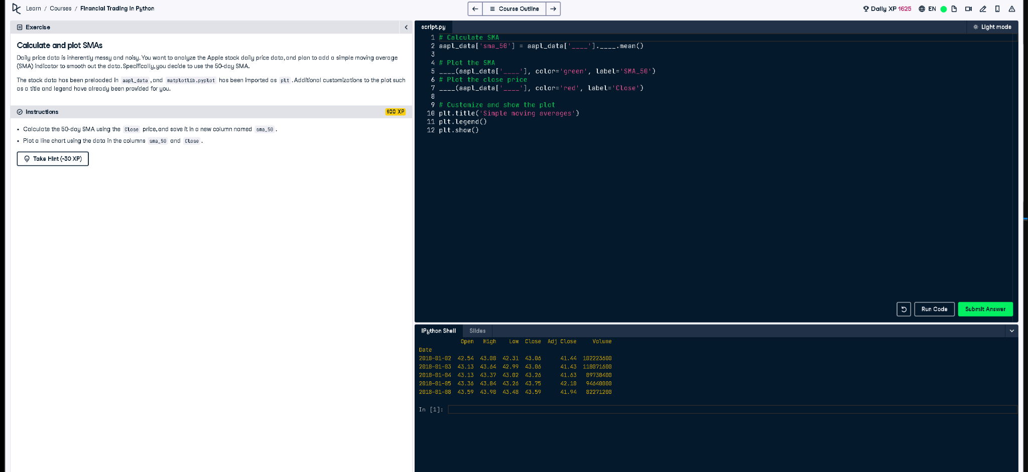
🐍 Full Python Code:
# Calculate SMA
aapl_data['sma_50'] = aapl_data['Close'].rolling(window=50).mean()
# Plot the SMA
plt.plot(aapl_data['sma_50'], color='green', label='SMA_50')
# Plot the close price
plt.plot(aapl_data['Close'], color='red', label='Close')
# Customize and show the plot
plt.title('Simple moving averages')
plt.legend()
plt.show()

